5MM Super Flux LED LAMPS |  |  |  |  |  |  |  | 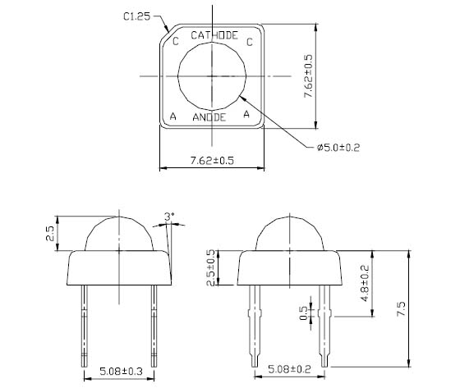
1.Package Outline Dimensions
2.Electrical & Optical Characteristics
Part No. | Color |  | Material |  |  | Lens Type |  | Typical Wavelength (Unit:nm,IF=20mA) |  |  |  |  |  |  | Luminous Intensity (Unit:lm，IF=20mA) |  |  |  |  | Forward Votage (Unit:V,IF=20mA) |  |  |  |  |  |  |  | Viewing angle 2θ1/2
 |  |  |  |  |  |  |  | λd |  |  | λp |  |  | △λ | Min |  |  |  | TYP | Min |  |  |  | TYP |  | Max
HT34-01SURC | Red |  | AlGaInP |  |  | Water clear |  | 624 |  |  | 632 |  |  | 20 | 800 |  |  |  | 1000 | … |  |  |  | 2,0 |  | 2,4 |  | 60
HT34-01UYOC | Orange |  | AlGaInP |  |  | Water clear |  | 605 |  |  | 611 |  |  | 17 | 800 |  |  |  | 1000 | … |  |  |  | 2,0 |  | 2,4 |  | 60
HT34-01UYC | Yellow |  | AlGaInP |  |  | Water clear |  | 589 |  |  | 591 |  |  | 15 | 800 |  |  |  | 1000 | … |  |  |  | 2,0 |  | 2,4 |  | 60
HT34-01SYGC | Yellow Green |  | AlGaInP |  |  | Water clear |  | 571 |  |  | 573 |  |  | 15 | 300 |  |  |  | 500 | … |  |  |  | 2,0 |  | 2,4 |  | 60
HT34-01UBGC | Green |  | InGaN |  |  | Water clear |  | 525 |  |  | 530 |  |  | 35 | 2000 |  |  |  | 3000 | … |  |  |  | 3,0 |  | 3,6 |  | 60
HT34-01UBC | Blue |  | InGaN |  |  | Water clear |  | 470 |  |  | 468 |  |  | 25 | 1000 |  |  |  | 2000 | … |  |  |  | 3,0 |  | 3,6 |  | 60
HT34-01UPC | Purple |  | InGaN |  |  | Water clear |  | 405 |  |  | 410 |  |  | 25 | 200 |  |  |  | 500 | … |  |  |  | 3,0 |  | 3,6 |  | 60
HT34-01UWC | White |  | InGaN |  |  | Yellow diffuse |  | x=0.29 y=0.28 |  |  | ** |  |  | ** | 2000 |  |  |  | 3000 | … |  |  |  | 3,0 |  | 3,6 |  | 60
HT34-01UWCA | Warm White |  | InGaN |  |  | Yellow diffuse |  | x=0.41 y=0.40 |  |  | ** |  |  | ** | 2000 |  |  |  | 3000 | … |  |  |  | 3,0 |  | 3,6 |  | 60

